**Names: MUGABO Christian**

**Reg number:21RP00278**

**Class:EAT Steam B**

**Air quality(pollution) Monitoring and Alert System**

# What is Air Pollution?

Air pollution is the presence of excessive amount of unwanted & harmful solid and gases substances in the air.

# Cause and Effect of Air Pollution

Recently, many cities in the world have encountered rapid urbanization and this has prompted expanded air pollution level. Air pollution is recognized as one of the main detriments to human health. Climate change is one of the most serious issue caused by the air pollution.

# How to Monitor the Air Pollution?

Air pollution is usually measure as Air Quality Index (AQI) in ppm, which is basically an index for measuring air pollution and various pollutants like PM 2.5, NO2, O3, CO, etc. Now a days due to growth of electronics components and availability of various sensors to measure the air pollutant different system is developed to monitor the amount of air pollutant in the air. In this article I will provide the details about Air Pollution Monitoring and Alter System using Arduino.

### **Working Explanation:**

The MQ-8 sensor can sense NH3, NOx, alcohol, Benzene, smoke, CO2 and some other gases, so it is perfect gas sensor for our **Air Quality Monitoring Project**. When we will connect it to Arduino then it will sense the gases, and we will get the Pollution level in PPM (parts per million). MQ-8 hydrogen gas sensor gives the output in form of voltage levels and we need to convert it into PPM. So for converting the output in PPM, here we have used a library for MQ-8 sensor, it is explained in detail in “Code Explanation” section below.

Sensor was giving us value of 90 when there was no gas near it and the safe level of air quality is 350 PPM and it should not exceed 1000 PPM. When it exceeds the limit of 1000 PPM, then it starts cause Headaches, sleepiness and stagnant, stale, stuffy air and if exceeds beyond 2000 PPM then it can cause increased heart rate and many other diseases.

When the value will be less than 1000 PPM, then the LCD and webpage will display “Fresh Air”.  Whenever the value will increase 1000 PPM, then the buzzer will start beeping and the LCD and webpage will display “Poor Air, Open Windows”. If it will increase 2000 then the buzzer will keep beeping and the LCD and webpage will display “Danger! Move to fresh Air”.

# Required Components:

* Arduino Uno
* MQ-8
* 16 × 2 LCD
* LED
* Buzzer
* Breadboard
* Connecting wires

# Working of each component:

# ARDUINO UNO:

# The **Arduino Uno** is one kind of microcontroller board based on ATmega328, and Uno is an Italian term which means one. Arduino Uno is named for marking the upcoming release of microcontroller board namely **Arduino Uno Board 1.0**. This board includes digital I/O pins-14, a power jack, analog i/ps-6, ceramic resonator-A16 MHz, a USB connection, an RST button, and an ICSP header. All these can support **the microcontroller** for further operation by connecting this board to the computer. The power supply of this board can be done with the help of an AC to DC adapter, a USB cable, otherwise a battery. This article discusses what is an **[Arduino Uno microcontroller](https://www.elprocus.com/what-is-arduino-uno-r3-pin-diagram-specification-and-applications/" \t "_blank)**, pin configuration, **Arduino Uno specifications or features**, and applications.

## What is Arduino Uno ATmega328?

The **ATmega328** is one kind of single-chip microcontroller formed with Atmel within the **megaAVR family**. The architecture of this Arduino Uno is a customized Harvard architecture with 8 bit **[RISC processor](https://www.elprocus.com/difference-between-risc-and-cisc-architecture/" \t "_blank)** core. **[Other boards of Arduino](https://www.elprocus.com/different-types-of-arduino-boards/" \t "_blank) Uno** include Arduino Pro Mini, Arduino Nano, Arduino Due, Arduino Mega, and Arduino Leonardo.

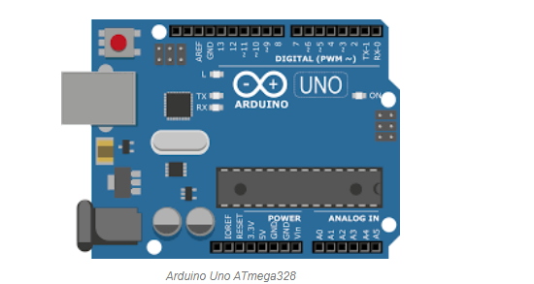

### Features of Arduino Uno Board

The **features of Arduino Uno ATmega328** includes the following.

* The operating voltage is 5V
* The recommended input voltage will range from 7v to 12V
* The input voltage ranges from 6v to 20V
* Digital input/output pins are 14
* Analog i/p pins are 6
* DC Current for each input/output pin is 40 mA
* DC Current for 3.3V Pin is 50 mA
* Flash Memory is 32 KB
* SRAM is 2 KB
* EEPROM is 1 KB
* CLK Speed is 16 MHz

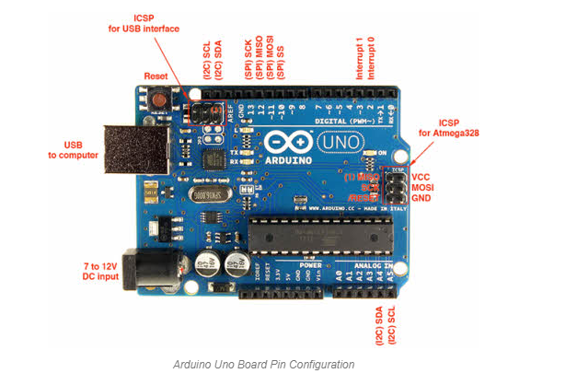

Arduino Uno Board Pin Configuration

**Power Supply**

The **Arduino Uno power supply** can be done with the help of a USB cable or an external power supply. The external power supplies mainly include AC to DC adapter otherwise a battery. The adapter can be connected to the Arduino Uno by plugging into the power jack of the Arduino board. Similarly, **[the battery](https://www.elprocus.com/an-overview-of-bio-battery-working-principle-types-applications/" \t "_blank)**leads can be connected to the Vin pin and the GND pin of the POWER connector. The suggested voltage range will be 7 volts to 12 volts.

**Input & Output**

The 14 digital pins on the Arduino Uno can be used as input & output with the help of the functions like pinMode(), digitalWrite(), & Digital Read().

**Pin1 (TX) & Pin0 (RX) (Serial):** This pin is used to transmit & receive TTL serial data, and these are connected to the ATmega8U2 USB to TTL Serial chip equivalent pins.

**Pin 2 & Pin 3 (External Interrupts):** External pins can be connected to activate an interrupt over a low value, change in value.

**Pins 3, 5, 6, 9, 10, & 11 (PWM):** This pin gives 8-bit PWM o/p by the function of analogWrite().

**SPI Pins (Pin-10 (SS), Pin-11 (MOSI), Pin-12 (MISO), Pin-13 (SCK):** These pins maintain SPI-communication, even though offered by the fundamental hardware, is not presently included within the Arduino language.

**Pin-13(LED):** The inbuilt LED can be connected to pin-13 (digital pin). As the HIGH-value pin, the light emitting diode is activated, whenever the pin is LOW.

**Pin-4 (SDA) & Pin-5 (SCL) (I2C):** It supports TWI-communication with the help of the Wire library.

**AREF (Reference Voltage):** The reference voltage is for the analog i/ps with analogReference().

**Reset Pin:** This pin is used for reset (RST) the microcontroller.

**Memory**

The memory of this Atmega328 Arduino microcontroller includes flash memory-32 KB for storing code, SRAM-2 KB EEPROM-1 KB.

**Communication**

The Arduino Uno ATmega328 offers UART TTL-**[serial communication](https://www.elprocus.com/i2c-bus-protocol-tutorial-interface-applications/" \t "_blank)**, and it is accessible on digital pins like TX (1) and RX (0). The software of an Arduino has a serial monitor that permits easy data. There are two LEDs on the board like RX & TX which will blink whenever data is being broadcasted through the USB.

A SoftwareSerial library permits for serial communication on Arduino Uno digital pins and the ATmega328P supports TWI (I2C) as well as **[SPI-communication](https://www.elprocus.com/serial-peripheral-interface-spi-communication-protocol/" \t "_blank)**. The Arduino software contains a wired library for simplifying the utilization of the I2C bus.

### How to Use an Arduino Uno?

Arduino Uno can detect the surroundings from the input. Here the input is a variety of sensors and these can affect its surroundings through controlling motors, lights, other actuators, etc. The ATmega328 microcontroller on the Arduino board can be programmed with the help of an Arduino programming language and the IDE (Integrated Development Environment). **[Arduino projects](https://www.elprocus.com/arduino-boards-electronics-and-electrical-engineering-projects/" \t "_blank)**can communicate by software while running on a PC.

### Arduino Programming

Once the Arduino IDE tool is installed in the PC, attach the Arduino board to the computer with the help of USB cable.  Open the Arduino IDE & select the right board by choosing Tools–>Board..>Arduino Uno, and select the right Port by choosing Tools–>Port. This board can be programmed with the help of an Arduino **[programming language](https://www.elprocus.com/8051-assembly-language-programming/" \t "_blank)** depends on Wiring.

To activate the Arduino board & [flash the LED](https://www.elprocus.com/blinking-led-using-555-timer-ic/" \t "_blank) on the board, dump the program code with the selection of Files–> Examples..>Basics..>Flash. When the programming codes are dumped into the IDE, and then click the button ‘upload’ on the top bar. Once this process is completed, check the LED flash on the board.

### High Voltage Protection of USB

The Arduino Uno board has a rearrangeable poly fuse that defends the USB port of the PC from the over-voltage. Though most of the PCs have their own inner protection, the fuse gives an additional coating of safety. If above 500mA is given to the USB port, then the fuse will routinely crack the connection until the over-voltage is removed.

### Physical Characteristics

The physical characteristics of an Arduino board mainly include length and width. The **[printed circuit board](https://www.elprocus.com/introduction-to-pcb-design-softwares-for-electronic-circuit-design/" \t "_blank)** of the Arduino Uno length and width are 2.7 X 2.1 inches, but the power jack and the USB connector will extend beyond the previous measurement. The board can be attached on the surface otherwise case with the screw holes.

### Applications of Arduino Uno ATmega328

The **applications of Arduino Uno** include the following.

* **[Arduino Uno](https://en.wikipedia.org/wiki/Arduino_Uno" \t "_blank)** is used in Do-it-Yourself projects prototyping.
* In developing projects based on code-based control
* Development of Automation System
* Designing of basic circuit designs.

Thus, this is all about **Arduino Uno datasheet**. From the above information finally, we can conclude that this is an 8-bit ATmega328P microcontroller. It has different components like serial communication, **[crystal oscillator](https://www.elprocus.com/crystal-oscillator-circuit-and-working/" \t "_blank)**, the voltage regulator for supporting [the microcontroller](https://www.elprocus.com/arm7-based-lpc2148-microcontroller-pin-configuration/" \t "_blank). This board includes a USB connection, digital I/O pins-14, analog i/p pins-6, a power-barrel jack, a reset button, and an ICSP header. Here is a question for you, what is the **Arduino Uno price in India**?

# I2C LCD DISPLAY

The character LCD is ideal for displaying text and numbers and special characters. LCDs incorporate a small add-on circuit (backpack) mounted on the back of the LCD module. The module features a controller chip handling I2C communications and an adjustable potentiometer for changing the intensity of the LED backlight. An I2C LCD advantage is that wiring is straightforward, requiring only two data pins to control the LCD.

A standard LCD requires over ten connections, which can be a problem if your Arduino does not have many GPIO pins available. If you happen to have an LCD without an I2C interface incorporated into the design, these can be easily **[acquired separately](https://www.pcboard.ca/iic-i2c-serial-interface-for-lcd" \t "_blank)**.

The LCD displays each character through a matrix grid of 5×8 pixels. These pixels can display standard text, numbers, or special characters and can also be programmed to display custom characters easily.

## How To Connect the I2C LCD to Arduino UNO

Connecting the Arduino UNO to the I2C interface of the LCD requires only four connections. The connections include two for power and two for data. The chart below shows the connections needed.

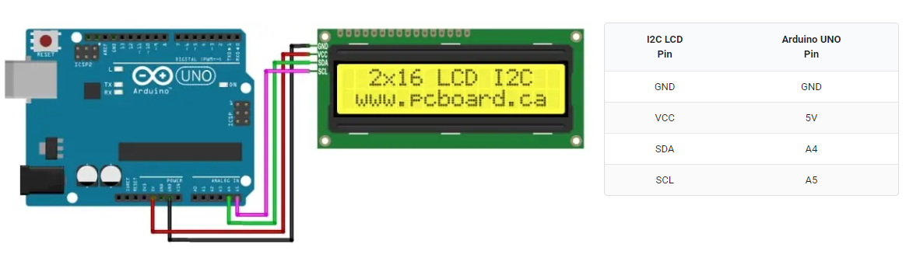

MQ-8(HYDROGEN GAS SENSOR):

A device that is used to detect the presence of hydrogen gas in the air is known as a Hydrogen sensor. These types of sensors include micro-fabricated point-contact hydrogen gas sensors which help in detecting hydrogen leaks. These sensors have many benefits such as being compact, less costly, simple to maintain, and strong.

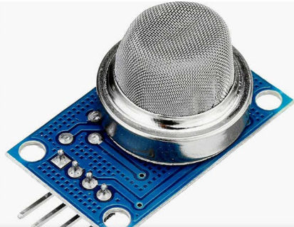

## **What is an MQ8 Hydrogen Sensor?**

* MQ8 hydrogen gas sensor is a Metal oxide semiconductor type sensor. This sensor is easy to use and detects hydrogen gas concentration in the range of 100-10000ppm anywhere.
* The sensitive material of the MQ-8 gas sensor is SnO2, which with lower conductivity in clean air. When hydrogen gas exists, the sensor’s conductivity gets higher along with the gas concentration rising. Users can convert the change of conductivity to correspond output signal of gas concentration through a simple circuit.
* MQ-8 gas sensor has a high sensitivity to hydrogen gas and also has anti-interference to other gases. This sensor can detect hydrogen, especially city gas. It is a kind of low-cost sensor for kinds of applications.

## **Pin Configuration**

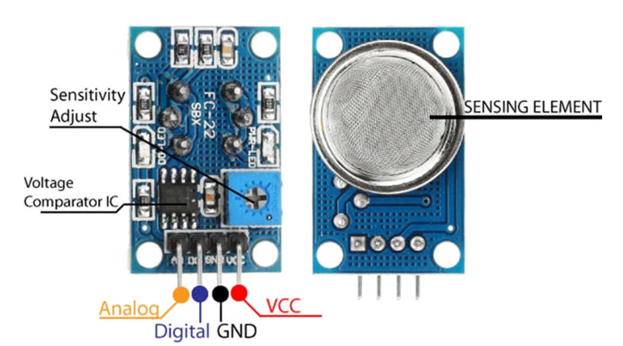

* **Pin1 (VCC):** This pin provides the input voltage for the sensor.
* **Pin2 (GND):** This is a Ground pin.
* **Pin3 (DOUT):** This is a digital signal output pin.
* **Pin4 (AOUT):** This is an analog signal output pin.

## **Working of an MQ-8 Hydrogen Gas Sensor**

* A gas sensor can detect the concentration of a specific gas in the air. Depending upon the concentration of the gas, the sensor generates a potential difference by changing the resistance of the sensing element, which can then be measured as the output voltage. MQ-8 hydrogen gas sensor consists of a sensing element which is aluminum-oxide-based ceramic, coated with tin dioxide (SnO2), enclosed in a stainless-steel mesh. In the case of any H2 in the air, the resistivity of the sensing element changes, and the change is measured to get the concentration of the gas present. MQ-8 sensor can detect H2 in the concentration range of 100-1000ppm.

## **Applications of MQ-8 Hydrogen Gas Sensor**

* Detect leakages in the industry.
* Used in mines.
* Can be used in refrigerators and AC
* hydrogen concentration within the air.

BUZZER

## What is a Buzzer?

An audio signaling device like a beeper or buzzer may be electromechanical or [piezoelectric](https://www.elprocus.com/what-is-a-piezoelectric-material-working/" \t "_blank) or mechanical type. The main function of this is to convert the signal from audio to sound. Generally, it is powered through DC voltage and used in timers, alarm devices, printers, alarms, computers, etc. Based on the various designs, it can generate different sounds like alarm, music, bell & siren.

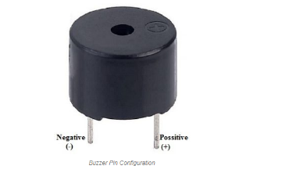

The **pin configuration of the buzzer** is shown below. It includes two pins namely positive and negative. The positive terminal of this is represented with the ‘+’ symbol or a longer terminal. This terminal is powered through 5Volts whereas the negative terminal is represented with the ‘-‘symbol or short terminal and it is connected to the GND terminal.

RED:

# Light Emitting Diode (LED)

**Definition:** The LED is a[PN-junction](https://circuitglobe.com/p-n-junction.html)diode which emits light when an [electric current](https://circuitglobe.com/electric-current.html)passes through it in the forward direction. In the LED, the recombination of charge carrier takes place. The electron from the N-side and the hole from the P-side are combined and gives the energy in the form of heat and light. The LED is made of [semiconductor](https://circuitglobe.com/semiconductors.html) material which is colourless, and the light is radiated through the junction of the diode.The LEDs are extensively used in segmental and dot matrix displays of numeric and alphanumeric character. The several LEDs are used for making the single line segment while for making the decimal point single LED is used.

BREAD BOAD

## **Introduction**

Breadboards are one of the most fundamental pieces when learning how to build circuits. In this tutorial, you will learn a little bit about what breadboards are, why they are called breadboards, and how to use one. Once you are done you should have a basic understanding of how breadboards work and be able to build a basic circuit on a breadboard.

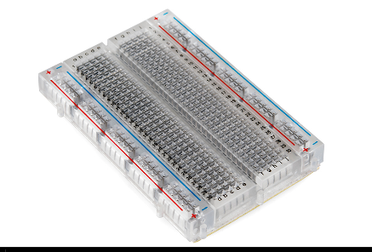

## **Why Use Breadboards?**

An electronics breadboard (as opposed to the type on which sandwiches are made) is actually referring to a **solderless breadboard**. These are great units for making temporary circuits and prototyping, and they require absolutely no soldering.

**Prototyping** is the process of testing out an idea by creating a preliminary model from which other forms are developed or copied, and it is one of the most common uses for breadboards. If you aren’t sure how a circuit will react under a given set of parameters, it’s best to build a prototype and test it out.

For those new to electronics and circuits, breadboards are often the best place to start. That is the real beauty of breadboards--they can house both the simplest circuit as well as very complex circuits. As you'll see later in this tutorial, if your circuit outgrows its current breadboard, others can be be attached to accommodate circuits of all sizes and complexities.

Another common use of breadboards is testing out new parts, such as Integrated circuits (ICs). When you are trying to figure out how a part works and constantly rewiring things, you don’t want to have to solder your connections each time.

As mentioned, you don’t always want the circuit you build to be permanent. When trying to duplicate a customer’s problem, SparkFun’s Technical Support team will often use breadboards to build, test, and analyze the circuit. They can connect the parts the customer has, and once they’ve gotten the circuit setup and figured out the problem, they can take everything apart and put it aside for the next time they need to do some troubleshooting.

# Interfacing circuit

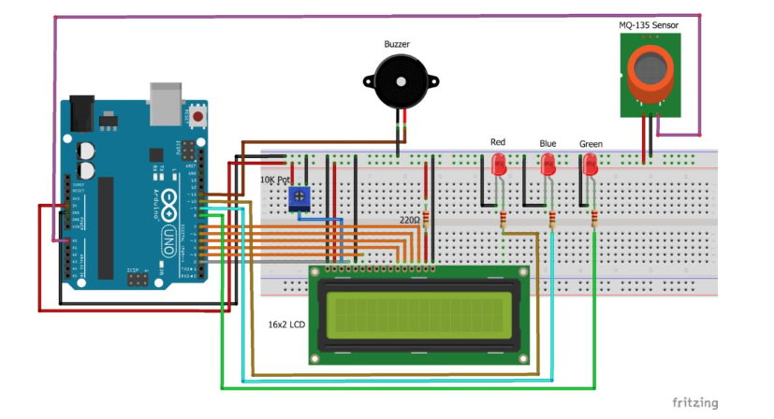

The best way to interface this circuit is to start with Arduino Uno board and LCD with breadboard. First place LCD on breadboard as shown in figure.

LCD to Arduino:

* D4 – Digital pin 5
* D5 – Digital pin 4
* D6 – Digital pin 3
* D7 – Digital pin 2
* E – Digital pin 11
* RS – Digital pin12

RS – Digital pin 12Now connect A to 220 ohm resistor to +5V and K to ground. Finally connect the VO to middle pin of potentiometer and VDD to +5V, VSS & RW to ground. Also provide +5V (brown wire) and Ground (black wire) to potentiometer as depicted in figure.

Okay, now it is very easy to interface other components. Connect MQ-8 A0 pin to A3 pin of Arduino and connect VCC to +5V and GND to Ground. Connect Anode (+) of LED to digital pin 9 Arduino and Cathode (-) to 220 ohm resistor to Ground. Then, connect buzzer’s positive terminal to +5V and negative terminal to collector of transistor and from base of transistor connect 1 K ohm resistor to digital pin 8 of Arduino, in the end connect emitter to ground.

# Working:

Arduino Uno is the main heart of this project and I have used MQ-8 Air Quality measurement sensor to measure AQI in ppm. So, first MQ-8 sensor will measure the amount of air pollutant in the air and provide the analog output to the A3 pin of the Arduino. Now, Arduino will send instructions to LCD for displaying the value of air quality provided by the MQ-8. Furthermore, to provide the alert to the user, I have set the threshold of 250 ppm in the code. So if measured AQI is more than 250 ppm then led will blink and buzzer will beep to alert the user about air quality.

# Code:

I have use Arduino IDE to program Arduino Uno board from https://utsource.net. So, first in the code we need to include the LiquidCrystal.h library header file.

**#include<LiquidCrystal.h>    //Header file for LCD**

**#include <LiquidCrstal\_I2C.h>**

Define the variables for different pins used in Arduino board for LCD, Buzzer, LED and MQ-8. Also, set threshold value as 250 ppm  
**LiquidCrystal\_I2C(0X27,16,2),**

**int buz = 8;                  //buzzer connected to pin 8**  
**int led = 9;                  //led connected to pin 9**  
**const int aqsensor = A0;      //output of mq8 connected to A0 pin of Arduino**  
**int threshold = 250;          //Threshold level for Air Quality**

This will run one time and here we need to set Buzzer, LED as output device and MQ-8 as input device to Arduino Uno. Serial UART and LCD is also initialized.

**void setup()**

**{**  
**pinMode(buz, OUTPUT);      // buzzer is connected as Output from Arduino**  
**pinMode(led, OUTPUT);      // led is connected as output from Arduino**  
**pinMode(aqsensor, INPUT);  // MQ8 is connected as INPUT to Arduino**  
**Serial.begin(9600);        // begin serial communication with baud rate of 9600**  
**lcd.clear();               // clear lcd**  
**lcd.begin(16, 2);          // consider 16,2 lcd**

**Lcd.backlight(),**  
**}**

This will run infinite times and here we write our logic to read MQ-8 sensor data and display it on LCD screen and condition to turn ON and OFF LED and Buzzer.

**void loop()**

**{**  
**int ppm = analogRead(aqsensor);    // read MQ135 analog outputs at A0 and store it in ppm**  
**Serial.print("Air Quality: ");     // print message in serail monitor**  
**Serial.println(ppm);               // print value of ppm in serial monitor**  
**lcd.setCursor(0, 0);               // set cursor of lcd to 1st row and 1st column**  
**lcd.print("Air Quality: ");         // print message on lcd**  
**lcd.print(ppm);                    // print value of MQ8**  
**if (ppm > threshold)               // check is ppm is greater than threshold or not**

**{**  
**lcd.setCursor(1, 1);             // jump here if ppm is greater than threshold**  
**lcd.print("AQ Level HIGH");**  
**Serial.println("AQ Level HIGH");**  
**tone(led, 1000, 200);            // blink led with turn on time 1000mS, turn off time 200mS**  
**digitalWrite(buz, HIGH);         // Turn ON Buzzer**  
**}**

**else**

**{**  
**digitalWrite(led, LOW);          // jump here if ppm is not greater than threshold and turn off LED**  
**digitalWrite(buz, LOW);          // Turn off Buzzer**  
**lcd.setCursor(1, 1);**  
**lcd.print("AQ Level Good");**  
**Serial.println("AQ Level Good");**  
**}**

**delay(500);**  
**}**

# Benefits of Air Quality Monitoring

Air quality is not same everywhere and it is different by geographic pattern and weather conditions along with sources of air pollution contributes towards the quality of air.

This is why different areas have different air quality levels at different time.

Example: Let’s consider two areas:

1. Area having low air exchange rate and less sources of air pollution
2. Area having high air exchange rate and less sources of air pollution

The first area will have a poor air quality than second area and why is that? This is because, the first area has low air exchange rate, which makes the pollutants to build up in that area and In second area, the air exchange rate is high which doesn’t allow the pollutants to build up in that particular area.

Read more about [Benefits of Environmental Monitoring](https://www.ppsthane.com/blog/benefits-environmental-monitoring)

Now I hope you get a clear idea that how different areas can have different air quality levels and this make it necessary to monitor air quality and to understand its benefits in details continue reading.

# Below are some Important Benefits of Air Quality Monitoring.

1. The data collected from air quality monitoring helps us assess impacts caused by poor air quality on public health.
2. Air quality data helps us determine if an area is meeting the air quality standards devised by CPCB, WHO or OSHA.
3. The data collected from air quality monitoring would primarily help us identify polluted areas, the level of pollution and air quality level.
4. Air quality monitoring would assist in determining if air pollution control programmes devised in a locality are working efficiently or not.
5. Air quality data helps us understand the mortality rate of any location due to air pollution. We can also assess and compare the short term and long term diseases/disorders which are a result of air pollution.
6. Based upon the data collected control measures can be devised for protection of environment and health of all living organisms.

Read More about [Importance of Stack emission Monitoring](https://www.ppsthane.com/blog/benefits-of-stack-emission-testing)

Basically Air Quality Monitoring Benefits us by helping us protect our mother earth and our lives. Air Quality Monitoring is the first step to understand air pollution and Regular Air Quality Monitoring would give us an exact idea about the pollution level in our surrounding and help us protect from various treacherous diseases.

Appication of **Air quality(Pollution) Monitoring and Alert System**

The data obtained from continuous air quality monitoring is used in different ways to help control and eliminate the dangers associated with air pollution. For example, many communities can benefit from r air quality monitoring in the following ways:

* Health experts can use the data to ascertain the effects air pollutants have on public health and safety.
* Effective air quality monitoring helps address specific sources of pollution and devise measures to stop or control the pollution.
* Equipped with timely and accurate data, residents, stakeholders and policymakers can make better and more informed decisions. They can also determine if an area is meeting the required air quality standards and, if not, what is hindering them from doing so.
* Data  reports also form the basis for research which can help show the correlation between pollution and health outcomes, and how improving air quality can improve the quality of life.
* air quality monitoring encourages response to situations that would turn disastrous if left to wait.

END!!!!!!!!!!